Use-Case Realization Report (Design)
Delete Page

Issue <1.0>
Revision History
Date | Issue | Description | Author
29/11/09 | 1.0 | Initial Version | Rajendran Kumaraguru

Table of Contents
1. Brief Description 4
2. Flow of Events 4
2.1 Standard Flow 4
2.2 Exception Flow 4
3. Interaction Diagrams 5
3.1 Sequence Diagram for Delete Page 5
4. Participating Objects 5
5. Class Diagrams 6
5.1 Class Diagram for Delete Page 6
6. Derived Requirements 6

Use-Case Realization Report (Design)
Delete Page

Brief Description
Portal admin will be able to perform the deletion of pages which is no longer needed or there would be complete change in the learning module. Also if the subscription of the service is already expired then the page can be deleted for the company.

Flow of Events

Standard Flow
- Portal Admin log into the system, and go to Page Admin Page.
- By clicking the “btnDelete_Click” button, the Page maintenance screen will be invoked in order to delete the page and its content for the created page.
- Get page will be invoked for the particular site before proceed to delete operation.
- Validate fields will be invoked to validate the input page details for the deletion operation.
- Delete Page will be performing the deletion operation for the page.
- Delete Module will be invoked to delete module detail.
- Upon deletion operation the successful message will be displayed to portal admin.

Exception Flow
- If the page is not available for the deletion then the exception message will be thrown.
- Validate fields should display respective error message if there is any validation error occurred.

Interaction Diagrams

Sequence Diagram for Delete Page
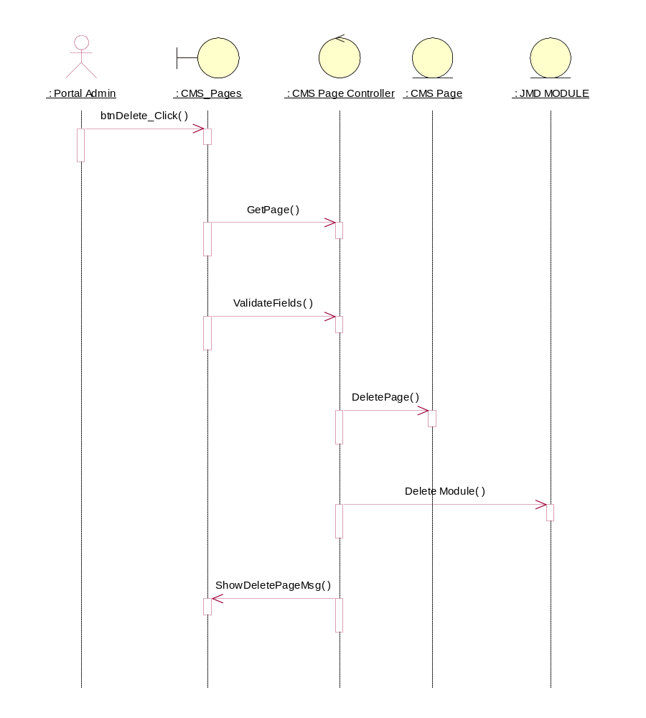

Participating Objects
: CMS Page

: CMS Page Controller

: CMS_Pages

: JMD MODULE

: Portal Admin

Class Diagrams

Class Diagram for Delete Page
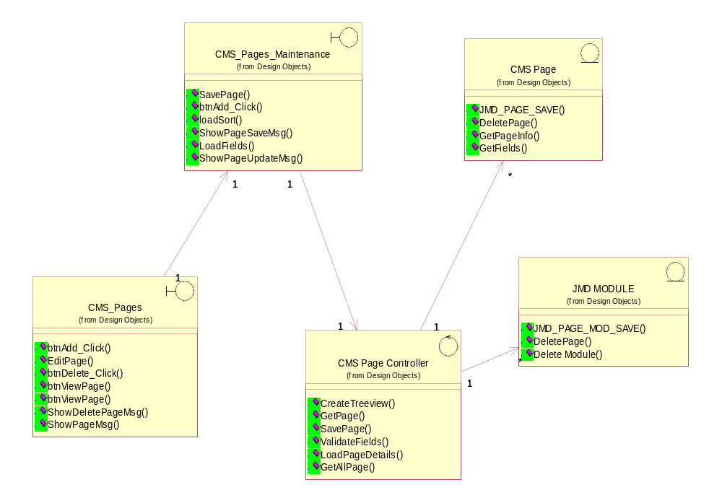

Derived Requirements
[enter the derived requirements here]

